

We are a StriveScan fair

We are excited to announce that we are a StriveScan college fair. Colleges will be able to scan our students and obtain their contact information using the StriveScan app. [Sign up to scan at www.strivescan.com](https://www.strivescan.com/)

A list of the college fairs that offer StriveScan is available on the [IACAC College Fair Calendar](https://www.iacac.org/college-fairs/) and in the StriveScan app.

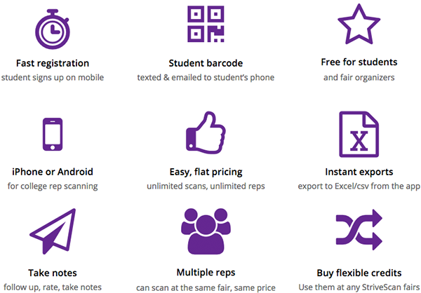

Handouts will be provided to students and signage at the door will encourage our students to complete a quick and easy registration right on their phones. They will be immediately texted and emailed a barcode that you can scan using the StriveScan app. At the conclusion of the fair, all of the students will be sent a report with a list of the colleges that scanned them, along with the school and rep’s contact information.

Colleges will be able to instantly export all of their student scans via the StriveScan app or website. The data is available immediately and provided in CSV (Excel) format for easy importing to your campus’ CRM or database.

**For more information about StriveScan:**

[www.strivescan.com](https://www.strivescan.com/)